SELF OPINION MINING FOR FEEDBACK MANAGEMENT SYSTEM
ABSTRACT
Online reviews have become an important source of information for users before making an informed purchase decision.Early reviews of a product tend to have a high impact on the subsequent product sales. In this paper, we take the initiative to study the behavior characteristics of early reviewers through their posted reviews on two real-world large e-commerce platforms, i.e., Amazon and Yelp. In specific, we divide product lifetime into three consecutive stages, namely early, majority and laggards. A user who has posted a review in the early stage is considered as an early reviewer. We quantitatively characterize early reviewers based on their rating behaviors, the helpfulness scores received from others and the correlation of their reviews with product popularity. We have found that (1) an early reviewer tends to assign a higher average rating score; and (2) an early reviewer tends to post more helpful reviews. Our analysis of product reviews also indicates that early reviewers’ ratings and their received helpfulness scores are likely to influence product popularity. By viewing review posting process as a multiplayer competition game, we propose a novel margin-based embedding model for early reviewer prediction. Extensive experiments on two different e-commerce datasets have shown that our proposed approach outperforms a number of competitive baselines.

INTRODUCTION
lead to the success of their new products. For this reason, early reviewers become the emphasis to monitor and attract at the early promotion stage of a company. The pivotal role of early reviews has attracted extensive attention from marketing practitioners to induce consumer purchase intentions [6]. For example, Amazon, one of the largest e-commerce company in the world, has advocated the Early Reviewer Program1 , which helps to acquire early reviews on products that have few or no reviews. With this program, Amazon shoppers can learn more about products and make smarter buying decisions. As another related program, Amazon Vine2 invites the most trusted reviewers on Amazon to post opinions about new and prerelease items to help their fellow customers make informed purchase decisions. Based on the above discussions, we can see that early reviewers are extremely important for product marketing. Thus, in this paper, we take the initiative to study the behavior characteristics of early reviewers through their posted reviews on representative e-commerce platforms, e.g., Amazon and Yelp. We aim to conduct effective analysis and make accurate prediction on early reviewers. This problem is strongly related to the adoption of innovations. In a generalized view, review posting process can be considered as an adoption of innovations3 , which is a theory that seeks to explain how, why, and at what rate new ideas and technology spread [8]. The analysis and detection of early adopters in the diffusion of innovations have attracted much attention from the research community. Three fundamental elements of a diffusion process have been studied: attributes of an innovation, communication channels, and social network structures [8]. However, most of these studies are theoretical analysis at the macro level and there is a lack of quantitative investigations. With the rapid growth of online social platforms and the availability of a high volume of social networking data, studies of the diffusion of innovations have been widely conducted on social networks [9]–[12].However, in many application domains, social networking links or communication channel are unobserved. Hence, existing methods relying on social network structures or communication channels are not suitable in our current problem of predicting early reviewers from online reviews.To model the behaviors of early reviewers, we develop a principled way to characterize the adoption process in two real-world large review datasets, i.e., Amazon and Yelp.
More specially, given a product, the reviewers are sorted according to their timestamps for publishing their reviews. Following [8], we divide the product lifetime into three consecutive stages, namely early, majority and laggards. A user who has posted a review in the early stage is considered as an early reviewer. In our work here, we mainly focus on two tasks, the first task is to analyze the overall characteristics of early reviewers compared with the majority and laggard reviewers. We characterize their rating behaviors and the helpfulness scores received from others and the correlation of their reviews with product popularity. The second task is
to learn a prediction model which predicts early reviewers given a product. To analyze the characteristics of early reviewers, we take two important metrics associated with their reviews, i.e., their review ratings and helpfulness scores assigned by others. We have found that (1) an early reviewer tends to assign a higher average rating score to products; and (2) an early reviewer tends to post more helpful reviews. Our above findings can find relevance in the classic principles of personality variables theory from social science, which mainly
studies how innovation is spread over time among the participants [8]: (1) earlier adopters have a more favorable
attitude toward changes than later adopters; and (2) earlier adopters have a higher degree of opinion leadership than later adopters. We can relate our findings with the personality variables theory as follows: higher average rating scores can be considered as the favorable attitude towards the products, and higher helpfulness votes of early reviews given by others can be viewed as a proxy measure of the opinion leadership. Our analysis also indicates that early reviewers’ ratings and their received helpfulness scores are likely to influence product popularity. We further explain this finding with the herd behavior widely studied in economics and sociology [13]–[15]. Herd behavior refers to the fact that individuals are strongly influenced by the decisions of others.
To predict early reviewers, we propose a novel approach by viewing review posting process as a multiplayer competition game. Only the most competitive users can become the early reviewers w.r.t. to a product. The competition process can be further decomposed into multiple pairwise comparisons between two players. In a two-player competition,the winner will beat the loser with an earlier timestamp. Inspired by the recent progress in distributed representation learning [16], [17], we propose to use a margin-based embedding model by first mapping both users and products into the same embedding space, and then determining the order of a pair of users given a product based on their respective distance to the product representation. Previous studies have highly emphasized the phenomenon that individuals are strongly influenced by the decisions of others, which can be explained by herd behavior [6], [13]–[15], [18]–[20]. The influence of early reviews on subsequent purchase can be understood as a special case of herding effect. Early reviews contain important product evaluations from previous adopters, which are valuable reference resources for subsequent purchase decisions. As shown in [19], when consumers use the product evaluations of others to estimate product quality on the Internet,herd behavior occurs in the online shopping process [19].Different from existing studies on herd behavior, we focus on quantitatively analyzing the overall characteristics of early reviewers using large-scale real-world datasets. In addition, we formalize the early reviewer prediction task as a competition problem and propose a novel embedding based ranking approach to this task. To our knowledge, the task of early reviewer prediction itself has received very little attention in the literature. Our contributions are summarized as follows:
• We present a first study to characterize early reviewers on an e-commerce website using two real-world large datasets.
• We quantitatively analyze the characteristics of early reviewers and their impact on product popularity.
Our empirical analysis provides support to a series of theoretical conclusions from the sociology and economics.
• We view review posting process as a multiplayer competition game and develop a embedding-based ranking model for the prediction of early reviewers.
Our model can deal with the cold-start problem by incorporating side information of products.
• Extensive experiments on two real-world large datasets, i.e., Amazon and Yelp have demonstrated the effectiveness of our approach for the prediction of early reviewers.
LITERATURE SERVAY
It has been reported that early adopters are important to the diffusion of innovations [8]. Hence, we hypothesize that early reviewers play a key role in future product adoptions.There has been a lack of quantitative analysis of the correlations between the early reviewers and product adoptions on large datasets, i.e., Amazon and Yelp. In this section, we study how early reviewers are different from others and how they impact product popularity.4.1 Characteristics of Early Reviewers To understand how early reviewers are different from others, we start with an analysis of their posted early reviews by looking into average ratings of the reviews and helpfulness scores voted by others. Using the categorization method discussed in Section 2, we assign each review into one of the three categories defined in Figure 2. Recall that each review is associated with a rating score and votes on its helpfulness.The rating score is in a five-star scale. For helpfulness, in Amazon data set, we count the number of Yes and No votes respectively and then normalize them to the range of [0, 1]. While in Yelp data set, users vote on the helpfulness of a review by clicking the Useful button. We count the number of Usefuls as the review’s helpfulness score. Given the three categories of reviews, we compute the average ratings and helpfulness scores in each review category.Early reviewers tend to assign a higher average rating score. We compare the average rating scores of reviews by the three categories in Figure 6. It is observed that early reviews are more likely to associate with a higher rating score than those from the other two categories. Note that we have removed spam reviews since their ratings tend to be extreme, either too high or too low. Early reviewers tend to post more helpful reviews. We compare the average helpfulness scores of reviews by the three categories in Figure 7. Note that Amazon dataset contains both Yes and No votes of reviews, we use the percentage of Yes votes to represent the helpfulness scores of a review. While in Yelp dataset, we use the number of Useful votes as the helpfulness score.
EXISTING SYSTEM
In this project student is predicting customer behaviour by analysing their review about products. If customer is happy with the product then he will write positive reviews else negative reviews. In this project we are using machine learning algorithms to predict sentiments from user reviews such as positive, negative or neutral.Earlier to predict SYSTEM ANALYSIS
customer satisfaction or behaviour existing techniques were using Naïve Bayes algorithm but its accuracy is low so we are introducing hybrid algorithm with the combination of KNN and decision tree. Hybrid algorithm giving better accuracy compare to Naïve Bayes algorithm.
PROPOSED SYSTEM:
In this implementation instead of calculating sentiments from customer reviews student asking to predict product ranking based on customer reviews and rating. To implement this we are converting all reviews to numeric values by applying CountVectorizer class. For each product we assign rank by taking average of ratings and then build train model using hybrid algorithm. After building trained model when we apply test data then trained model will predict rank and give output.

Modules Details
Upload Amazon Reviews Dataset: using this module we will upload amazon dataset to application
Tokenization & Pre-processing: Using this module we will read reviews and rating from dataset and then tokenize reviews into words and then by applying pre-processing technique we remove stop words and then apply stemming technique to get root word.
Train & Test Model: using this module we will select features from dataset and then split dataset into train and test part. Application used 80% dataset for training and 20% dataset for testing.
Build Classifier: Using this module we will generate train model of Naïve Bayes and Hybrid algorithm and obtained their prediction accuracy.
Run: Using this module we will take reviews and rating from user and then convert reviews into numeric values and then apply hybrid trained model on review and ratings to get product rank.In amazon dataset we have reviews of KINDLE tab.
REQUIREMENT ANALYSIS
The project involved analyzing the design of few applications so as to make the application more users friendly. To do so, it was really important to keep the navigations from one screen to the other well ordered and at the same time reducing the amount of typing the user needs to do. In order to make the application more accessible, the browser version had to be chosen so that it is compatible with most of the Browsers.
REQUIREMENT SPECIFICATION
Functional Requirements
- Graphical User interface with the User.

Software Requirements
For developing the application the following are the Software Requirements:
- Python
- Django
- Mysql
- Wampserver

Operating Systems supported
- Windows 7
- Windows XP
- Windows 8
Technologies and Languages used to Develop
- Python
Debugger and Emulator
- Any Browser (Particularly Chrome)
Hardware Requirements
For developing the application the following are the Hardware Requirements:
- Processor: Pentium IV or higher
- RAM: 256 MB
- Space on Hard Disk: minimum 512MB

SYSTEM ARCHITECTURE

System architecture
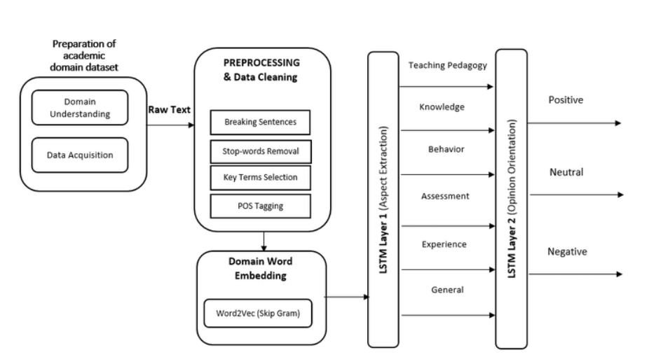
SYSTEM DESIGN
Class Diagram
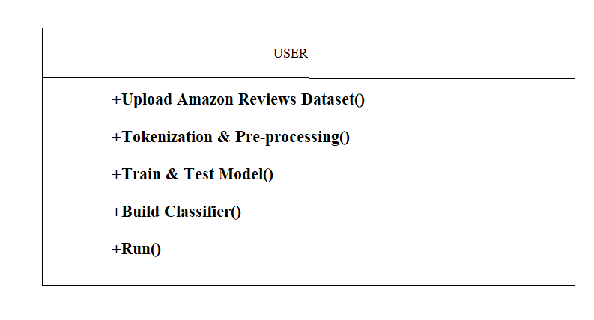
USE CASE
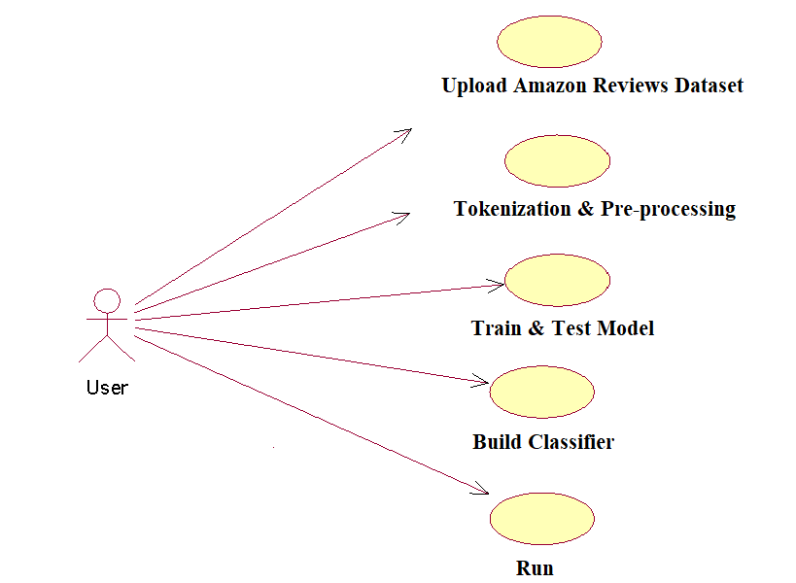
Sequence Diagram
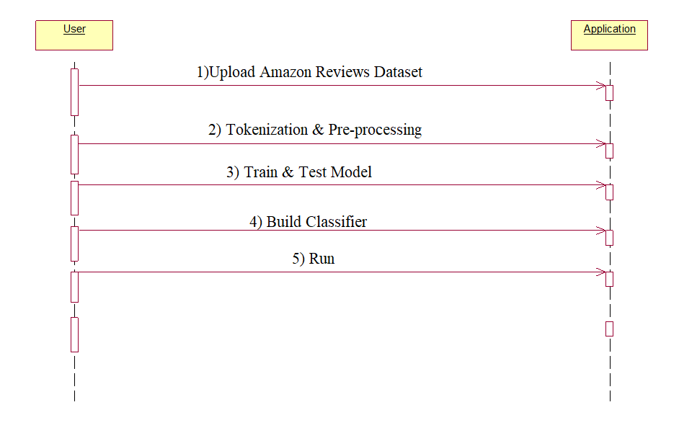
Collaboration diagram
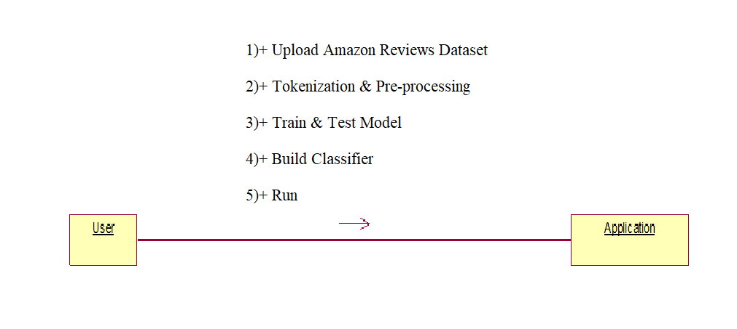

SYSTEM STUDY
FEASIBILITY STUDY
The feasibility of the project is analyzed in this phase and business proposal is put forth with a very general plan for the project and some cost estimates. During system analysis the feasibility study of the proposed system is to be carried out. This is to ensure that the proposed system is not a burden to the company. For feasibility analysis, some understanding of the major requirements for the system is essential.
Three key considerations involved in the feasibility analysis are,
- ECONOMICAL FEASIBILITY
- TECHNICAL FEASIBILITY
- SOCIAL FEASIBILITY
ECONOMICAL FEASIBILITY
This study is carried out to check the economic impact that the system will have on the organization. The amount of fund that the company can pour into the research and development of the system is limited. The expenditures must be justified. Thus the developed system as well within the budget and this was achieved because most of the technologies used are freely available. Only the customized products had to be purchased.

TECHNICAL FEASIBILITY
This study is carried out to check the technical feasibility, that is, the technical requirements of the system. Any system developed must not have a high demand on the available technical resources. This will lead to high demands on the available technical resources. This will lead to high demands being placed on the client. The developed system must have a modest requirement, as only minimal or null changes are required for implementing this system.

SOCIAL FEASIBILITY
The aspect of study is to check the level of acceptance of the system by the user. This includes the process of training the user to use the system efficiently. The user must not feel threatened by the system, instead must accept it as a necessity. The level of acceptance by the users solely depends on the methods that are employed to educate the user about the system and to make him familiar with it. His level of confidence must be raised so that he is also able to make some constructive criticism, which is welcomed, as he is the final user of the system.

IMPLIMENTATION

from tkinter import messagebox
from tkinter import *
from tkinter import simpledialog
import tkinter
import matplotlib.pyplot as plt
import numpy as np
import pandas as pd
from tkinter import simpledialog
from tkinter import filedialog
import os
from sklearn.feature_extraction.text import CountVectorizer
import re
from string import punctuation
from nltk.corpus import stopwords
from sklearn.naive_bayes import MultinomialNB
from sklearn.neighbors import KNeighborsClassifier
from sklearn.tree import DecisionTreeClassifier
from sklearn.metrics import accuracy_score
from sklearn.model_selection import train_test_split
from sklearn.ensemble import VotingClassifier
import pickle
from sklearn.naive_bayes import BernoulliNB
stop_words = set(stopwords.words('english'))

main = tkinter.Tk()
main.title("SELF OPINION MINING FOR FEEDBACK MANAGEMENT SYSTEM") #designing main screen
main.geometry("1300x1200")

global filename
global X, Y
global X_train, X_test, Y_train, Y_test
global cv
global XX
rank = {}
global cls
global nb_acc,hybrid_acc

def upload():
global filename
global rank
rank.clear()
train = pd.read_csv('dataset/rank.csv')
for i in range(len(train)):
ids = train.get_value(i,0,takeable = True)
rank_value = train.get_value(i,1,takeable = True)
rank[ids] = rank_value
filename = filedialog.askopenfilename(initialdir="dataset")
text.delete('1.0', END)
text.insert(END,filename+" loaded\n");

def checkInput(inputdata):
option = 0
try:
s = float(inputdata)
option = 0
except:
option = 1
return option

def clean_doc(doc):
tokens = doc.split()
table = str.maketrans('', '', punctuation)
tokens = [w.translate(table) for w in tokens]
tokens = [word for word in tokens if word.isalpha()]
stop_words = set(stopwords.words('english'))
tokens = [w for w in tokens if not w in stop_words]
tokens = [word for word in tokens if len(word) > 1]
tokens = ' '.join(tokens) #here upto for word based
return tokens

def Preprocessing():
global X
global Y
X = []
Y = []
text.delete('1.0', END)
train = pd.read_csv(filename)
train['reviews.rating'] = train['reviews.rating'].fillna(0)
two = 0
three = 0
four = 0
five = 0
for i in range(len(train)):
ids = train.get_value(i,"id")
ratings = train.get_value(i,"reviews.rating")
review = train.get_value(i,"reviews.text")
temp = review
rank_value = rank.get(ids)
check = checkInput(review)
if check == 1:
review = review.lower().strip()
review = clean_doc(review)
arr = review.split(" ")
msg = ''
for k in range(len(arr)):
word = arr[k].strip()
if len(word) > 2 and word not in stop_words:
msg+=word+" "
textdata = msg.strip() #+" "+icon
if two <= 500 and rank_value == 2:
X.append(textdata+" "+str(int(ratings)))
Y.append(rank_value)
print(str(i)+"=="+str(ids)+"==="+str(ratings)+" == "+str(temp)+" "+str(rank_value))
if three <= 500 and rank_value == 3:
X.append(textdata+" "+str(int(ratings)))
Y.append(rank_value)
print(str(i)+"=="+str(ids)+"==="+str(ratings)+" == "+str(temp)+" "+str(rank_value))
if four <= 500 and rank_value == 4:
X.append(textdata+" "+str(int(ratings)))
Y.append(rank_value)
print(str(i)+"=="+str(ids)+"==="+str(ratings)+" == "+str(temp)+" "+str(rank_value))
if five <= 500 and rank_value == 5:
X.append(textdata+" "+str(int(ratings)))
Y.append(rank_value)
print(str(i)+"=="+str(ids)+"==="+str(ratings)+" == "+str(temp)+" "+str(rank_value))
if rank_value == 2:
two = two + 1
if rank_value == 3:
three = three + 1
if rank_value == 4:
four = four + 1
if rank_value == 5:
five = five + 1
X = np.asarray(X)
Y = np.asarray(Y)
print(Y)
text.insert(END,'Total reviews found in dataset : '+str(len(X))+"\n")

def generateModel():
global cls
text.delete('1.0', END)
global XX
global cv
global X_train, X_test, Y_train, Y_test
cv = CountVectorizer(analyzer='word',stop_words = stop_words, lowercase = True)
XX = cv.fit_transform(X).toarray()
'''
max_fatures = 541
tokenizer = Tokenizer(num_words=max_fatures, split=' ')
tokenizer.fit_on_texts(X)
XX = tokenizer.texts_to_sequences(X)
XX = pad_sequences(XX)
'''
X_train, X_test, Y_train, Y_test = train_test_split(XX,Y, test_size = 0.13, random_state = 0)

print(X_train[0])
text.insert(END,'Total features extracted from reviews are : '+str(X_train.shape)+"\n")
text.insert(END,'Total splitted records used for training : '+str(len(X_train))+"\n")
text.insert(END,'Total splitted records used for testing : '+str(len(X_test))+"\n")

def buildClassifier():
global nb_acc,hybrid_acc
global cls
text.delete('1.0', END)
naiveBayes = BernoulliNB(binarize=5.5)
naiveBayes.fit(X_train, Y_train)
y_pred = naiveBayes.predict(X_test)
nb_acc = accuracy_score(Y_test,y_pred)*100
text.insert(END,"Naive Bayes Accuracy : "+str(nb_acc)+"\n\n")

knn = KNeighborsClassifier()
dt = DecisionTreeClassifier(max_depth=500, min_samples_split=10,random_state=0)
cls = VotingClassifier(estimators = [('dt', dt), ('knn', knn)], voting = 'soft')
cls.fit(X_train, Y_train)
y_pred = cls.predict(X_test)
hybrid_acc = accuracy_score(Y_test,y_pred)*100
text.insert(END,"Hybrid KNN & Decision Tree Accuracy : "+str(hybrid_acc)+"\n\n")
f = open('cls.pckl', 'wb')
pickle.dump(cls, f)
f.close()

def predictRanking():
'''
f = open('cls.pckl', 'rb')
cls = pickle.load(f)
f.close()
'''
text.delete('1.0', END)
global cls
review = tf1.get()
rating = tf2.get()
textdata = review.strip()
textdata = textdata.lower()
textdata = clean_doc(textdata)
arr = textdata.split(" ")
msg = ''
for k in range(len(arr)):
word = arr[k].strip()
if len(word) > 2 and word not in stop_words:
msg+=word+" "
textdata = msg.strip()
textdata = textdata.strip()+" "+rating.strip()
print(textdata)
cv1 = CountVectorizer(vocabulary=cv.get_feature_names(),stop_words = "english", lowercase = True)
test1 = cv1.fit_transform([textdata])
output = cls.predict(test1.toarray())[0]
text.insert(END,'REVIEW: '+tf1.get()+"\n")
text.insert(END,'RATING: '+tf2.get()+"\n\n")
text.insert(END,'Predicted Ranking for above review & rating is : '+str(output))

def graph():
height = [nb_acc,hybrid_acc]
bars = ('Naive Bayes Accuracy','Hybrid Algorithm Accuracy')
y_pos = np.arange(len(bars))
plt.bar(y_pos, height)
plt.xticks(y_pos, bars)
plt.show()

font = ('times', 16, 'bold')
title = Label(main, text='Characterizing Customer Early Reviews')
title.config(bg='LightGoldenrod1', fg='medium orchid')
title.config(font=font)
title.config(height=3, width=120)
title.place(x=0,y=5)

font1 = ('times', 12, 'bold')
text=Text(main,height=20,width=100)
scroll=Scrollbar(text)
text.configure(yscrollcommand=scroll.set)
text.place(x=10,y=300)
text.config(font=font1)

font1 = ('times', 12, 'bold')
uploadButton = Button(main, text="Upload Amazon Reviews Dataset", command=upload)
uploadButton.place(x=50,y=100)
uploadButton.config(font=font1)

preButton = Button(main, text="Tokenization & Preprocessing", command=Preprocessing)
preButton.place(x=320,y=100)
preButton.config(font=font1)

modelButton = Button(main, text="Generate Train Test Model with FS", command=generateModel)
modelButton.place(x=570,y=100)
modelButton.config(font=font1)

classifierButton = Button(main, text="Build Classifier", command=buildClassifier)
classifierButton.place(x=860,y=100)
classifierButton.config(font=font1)

l1 = Label(main, text='Enter Reviews')
l1.config(font=font1)
l1.place(x=50,y=150)

tf1 = Entry(main,width=40)
tf1.config(font=font1)
tf1.place(x=200,y=150)

l2 = Label(main, text='Enter Rating')
l2.config(font=font1)
l2.place(x=50,y=200)

tf2 = Entry(main,width=40)
tf2.config(font=font1)
tf2.place(x=200,y=200)

runButton = Button(main, text="Run", command=predictRanking)
runButton.place(x=100,y=250)
runButton.config(font=font1)

graphButton = Button(main, text="Comparison Graph Naive Bayes & Hybrid Algorithm", command=graph)
graphButton.place(x=160,y=250)
graphButton.config(font=font1)

main.config(bg='OliveDrab2')
main.mainloop()

SYSTEM TESTING:
SYSTEM TEST
The purpose of testing is to discover errors. Testing is the process of trying to discover every conceivable fault or weakness in a work product. It provides a way to check the functionality of components, sub assemblies, assemblies and/or a finished product It is the process of exercising software with the intent of ensuring that the Software system meets its requirements and user expectations and does not fail in an unacceptable manner. There are various types of test. Each test type addresses a specific testing requirement.

TYPES OF TESTS

Unit testing
Unit testing involves the design of test cases that validate that the internal program logic is functioning properly, and that program inputs produce valid outputs. All decision branches and internal code flow should be validated. It is the testing of individual software units of the application .it is done after the completion of an individual unit before integration. This is a structural testing, that relies on knowledge of its construction and is invasive. Unit tests perform basic tests at component level and test a specific business process, application, and/or system configuration. Unit tests ensure that each unique path of a business process performs accurately to the documented specifications and contains clearly defined inputs and expected results.

Integration testing
Integration tests are designed to test integrated software components to determine if they actually run as one program. Testing is event driven and is more concerned with the basic outcome of screens or fields. Integration tests demonstrate that although the components were individually satisfaction, as shown by successfully unit testing, the combination of components is correct and consistent. Integration testing is specifically aimed at exposing the problems that arise from the combination of components.

Functional test

Functional tests provide systematic demonstrations that functions tested are available as specified by the business and technical requirements, system documentation, and user manuals.
Functional testing is centered on the following items:
Valid Input : identified classes of valid input must be accepted.
Invalid Input : identified classes of invalid input must be rejected.
Functions : identified functions must be exercised.
Output : identified classes of application outputs must be exercised.
Systems/Procedures : interfacing systems or procedures must be invoked.
Organization and preparation of functional tests is focused on requirements, key functions, or special test cases. In addition, systematic coverage pertaining to identify Business process flows; data fields, predefined processes, and successive processes must be considered for testing. Before functional testing is complete, additional tests are identified and the effective value of current tests is determined.

System Test
System testing ensures that the entire integrated software system meets requirements. It tests a configuration to ensure known and predictable results. An example of system testing is the configuration oriented system integration test. System testing is based on process descriptions and flows, emphasizing pre-driven process links and integration points.

White Box Testing
White Box Testing is a testing in which in which the software tester has knowledge of the inner workings, structure and language of the software, or at least its purpose. It is purpose. It is used to test areas that cannot be reached from a black box level.

Black Box Testing

Black Box Testing is testing the software without any knowledge of the inner workings, structure or language of the module being tested. Black box tests, as most other kinds of tests, must be written from a definitive source document, such as specification or requirements document, such as specification or requirements document. It is a testing in which the software under test is treated, as a black box .you cannot “see” into it. The test provides inputs and responds to outputs without considering how the software works.
Unit Testing
Unit testing is usually conducted as part of a combined code and unit test phase of the software lifecycle,. although it is not uncommon for coding and unit testing to be conducted as two distinct phases
Test strategy and approach
Field testing will be performed manually and functional tests will be written in detail.
Test objectives
- All field entries must work properly.
- Pages must be activated from the identified link.
- The entry screen, messages and responses must not be delayed.

Features to be tested
- Verify that the entries are of the correct format
- No duplicate entries should be allowed
- All links should take the user to the correct page.

Integration Testing
Software integration testing is the incremental integration testing of two or more integrated software components on a single platform to produce failures caused by interface defects.
The task of the integration test is to check that components or software applications, e.g. components in a software system or – one step up – software applications at the company level – interact without error.
Test Results: All the test cases mentioned above passed successfully. No defects encountered.

Acceptance Testing
User Acceptance Testing is a critical phase of any project and requires significant participation by the end user. It also ensures that the system meets the functional requirements.
Test Results: All the test cases mentioned above passed successfully. No defects encountered.
INPUT AND OUTPUT DESIGN
INPUT DESIGN
The input design is the link between the information system and the user. It comprises the developing specification and procedures for data preparation and those steps are necessary to put transaction data in to a usable form for processing can be achieved by inspecting the computer to read data from a written or printed document or it can occur by having people keying the data directly into the system. The design of input focuses on controlling the amount of input required, controlling the errors, avoiding delay, avoiding extra steps and keeping the process simple. The input is designed in such a way so that it provides security and ease of use with retaining the privacy. Input Design considered the following things:
- What data should be given as input?
- How the data should be arranged or coded?
- The dialog to guide the operating personnel in providing input.
- Methods for preparing input validations and steps to follow when error occur.

OBJECTIVES
1.Input Design is the process of converting a user-oriented description of the input into a computer-based system. This design is important to avoid errors in the data input process and show the correct direction to the management for getting correct information from the computerized system.
2. It is achieved by creating user-friendly screens for the data entry to handle large volume of data. The goal of designing input is to make data entry easier and to be free from errors. The data entry screen is designed in such a way that all the data manipulates can be performed. It also provides record viewing facilities.
3.When the data is entered it will check for its validity. Data can be entered with the help of screens. Appropriate messages are provided as when needed so that the user will not be in maize of instant. Thus the objective of input design is to create an input layout that is easy to follow

OUTPUT DESIGN
A quality output is one, which meets the requirements of the end user and presents the information clearly. In any system results of processing are communicated to the users and to other system through outputs. In output design it is determined how the information is to be displaced for immediate need and also the hard copy output. It is the most important and direct source information to the user. Efficient and intelligent output design improves the system’s relationship to help user decision-making.
1. Designing computer output should proceed in an organized, well thought out manner; the right output must be developed while ensuring that each output element is designed so that people will find the system can use easily and effectively. When analysis design computer output, they should Identify the specific output that is needed to meet the requirements.
2.Select methods for presenting information.
3.Create document, report, or other formats that contain information produced by the system.
The output form of an information system should accomplish one or more of the following objectives.
- Convey information about past activities, current status or projections of the
- Future.
- Signal important events, opportunities, problems, or warnings.
- Trigger an action.
- Confirm an action.

Screen shots
To run project double click on ‘run.bat’ file to get below screen
In above screen click on ‘Upload Amazon Reviews Dataset’ button and upload dataset
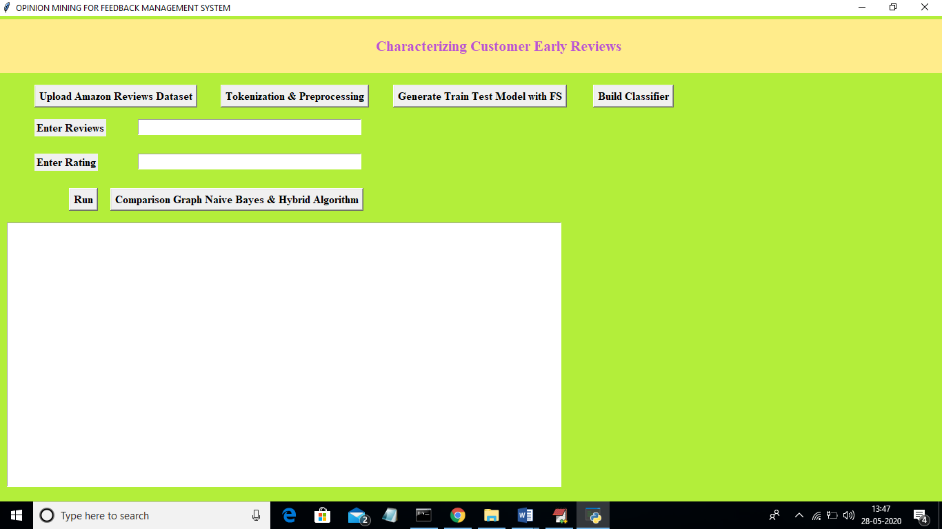
In above screen click on ‘Upload Amazon Reviews Dataset’ button and upload dataset
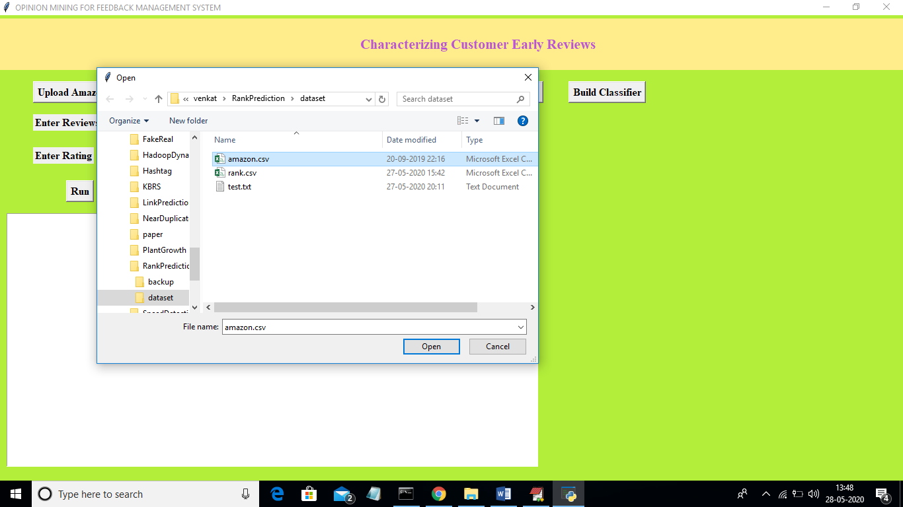
In above screen I am uploading ‘amazon.csv’ dataset file and now click on ‘Open’ button to load dataset
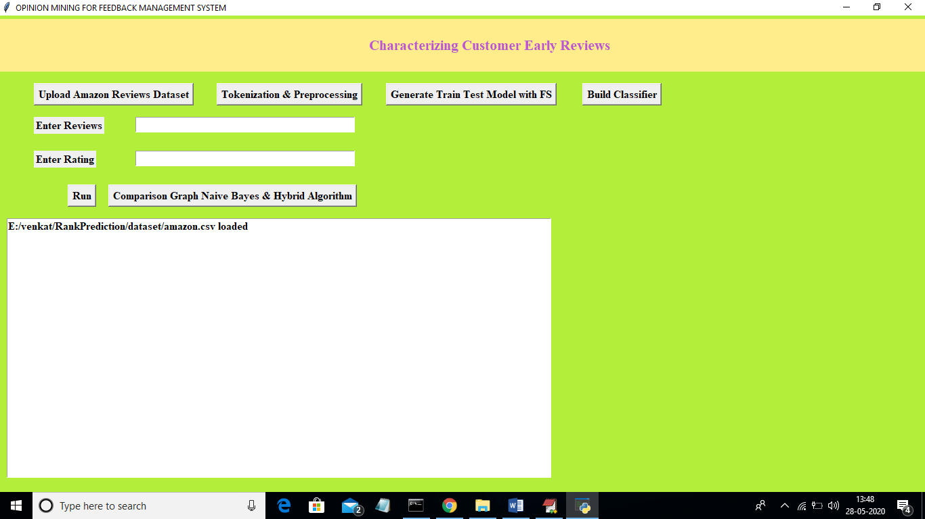
In above screen dataset loaded and now click on ‘Tokenization & Pre-processing’ button to read reviews from dataset and then split/tokenize reviews into words and then remove stop words and apply stemming technique to get root words .

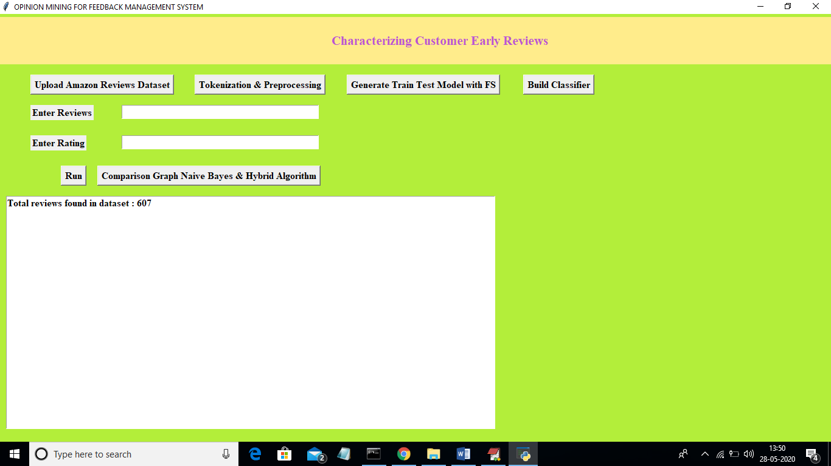
In above screen from total dataset application read 607 reviews. I am reading only few reviews as this normal computers cannot build machine learning algorithm with huge records. Normal computers will take hours of time to build model for all records so I am reading only 600 records and there reviews and ratings. Now click on ‘Generate Train Test Model with FS’ button to split dataset into train and test model and use only important features using FS algorithm.
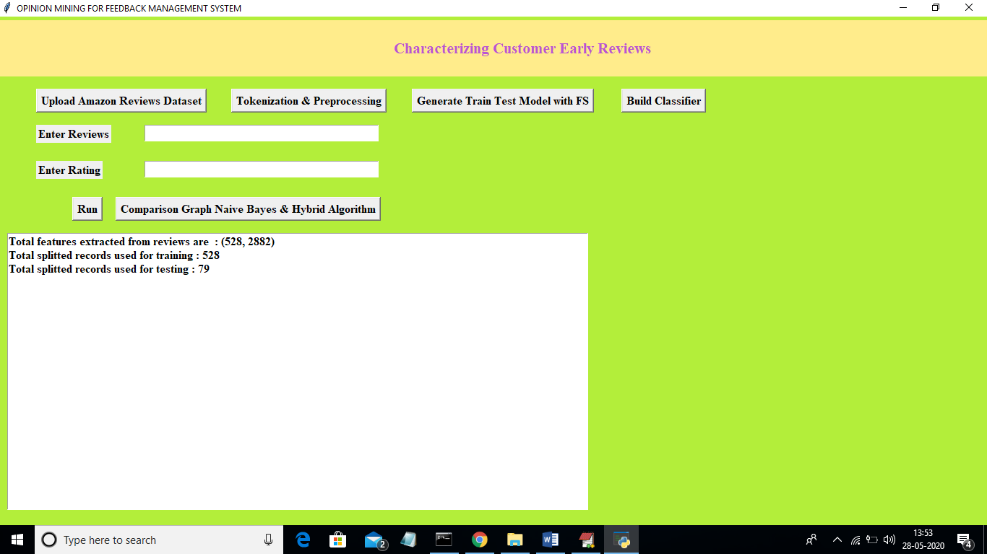
In above screen we can see from 607 reviews records application using 528 records for training and 79 records for testing and in all 607 records we got total unique reviews words are 2882. Now click on ‘Build Classifier’ button to generate training model using Naïve Bayes and Hybrid Algorithm
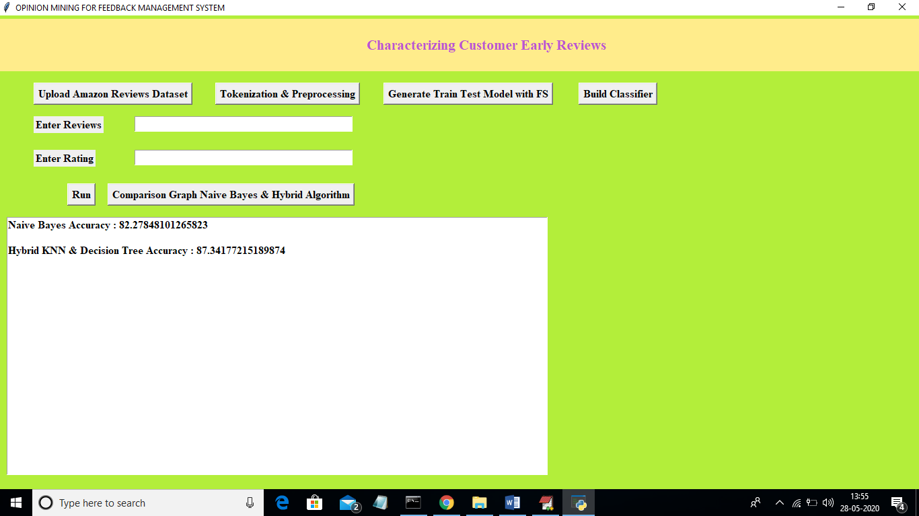
In above screen with Naïve Bayes we got 82.27% accuracy and with Hybrid algorithm we got 87.34% prediction accuracy. Now enter your reviews and rating to get rank and reviews u can take values from ‘test.txt’ file.
Note: classifier predict ranking for only those words which are available in trained model. If you give words which are not available in trained model then you may get incorrect value. Here for ranking we have values from 1 to 5 and there is chance that some words in rank 4 class may available in rank 5 class at that situation also we may get either value as output. Example
Review Rating
IPhone is good but its charger is not good 3
IPhone and its screen is good 5
In above sentence ‘good’ appear for different class rating at that situation we may get either 3 or 5 as predicted ranking. In first sentence customer is happy with phone but not with charger.
So to avoid such problems you can use reviews similar or same from ‘test.txt’ file
In above screen with Naïve Bayes we got 82.27% accuracy and with Hybrid algorithm we got 87.34% prediction accuracy. Now enter your reviews and rating to get rank and reviews u can take values from ‘test.txt’ file.
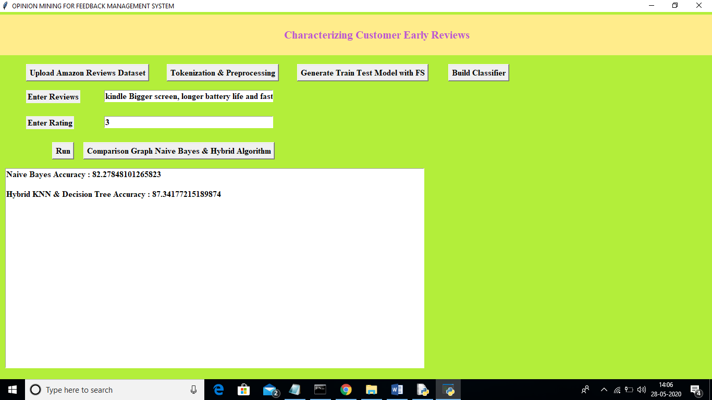
In above screen I entered some reviews and rating and now click on ‘Run’ button to get rank of product
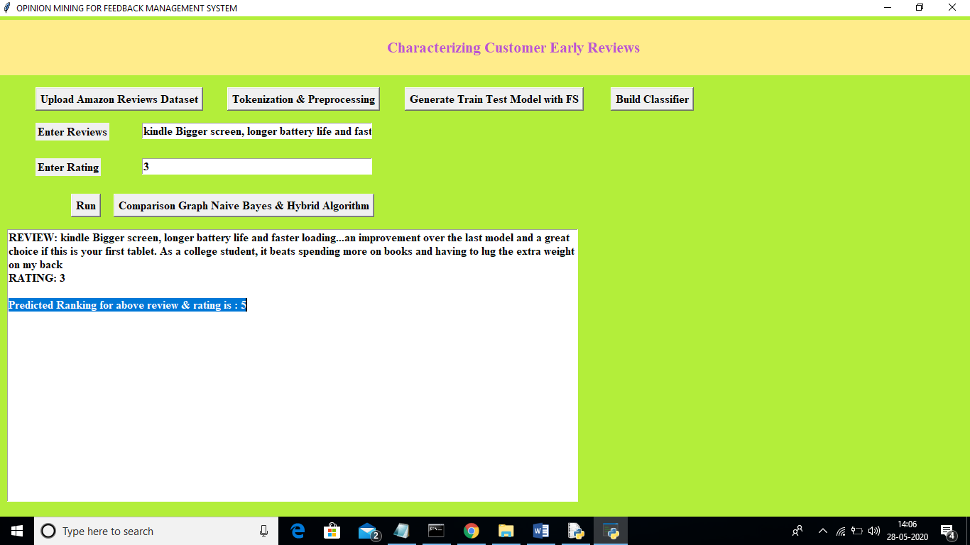
In above screen for given review and rating we got product rank as 5. Similarly you can enter your own reviews or from test.txt to get product rank. Now click on ‘Comparison Graph Naïve Bayes & Hybrid Algorithm’ button to get below graph
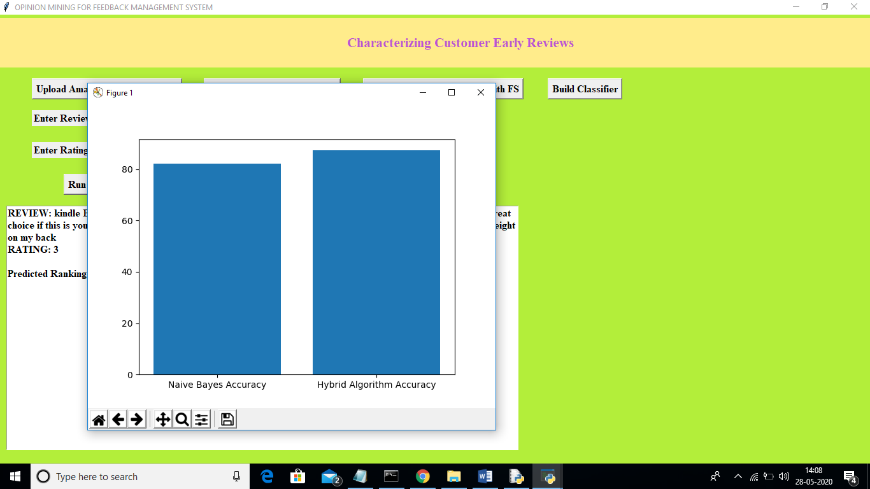
In above graph x-axis represents algorithm names and y-axis represents accuracy of those algorithms. From above graph we can conclude that hybrid algorithm got higher accuracy compare to naïve bayes.

CONCLUSION
In this paper, we have studied the novel task of early reviewer characterization and prediction on two real-world online review datasets. Our empirical analysis strengthens a series of theoretical conclusions from sociology and economics. We found that (1) an early reviewer tends to assign a higher average rating score; and (2) an early reviewer tends to post more helpful reviews. Our experiments also indicate that early reviewers’ ratings and their received helpfulness scores are likely to influence product popularity at a later stage. We have adopted a competition-based viewpoint to model the review posting process, and developed a marginbased embedding ranking model (MERM) for predicting early reviewers in a cold-start setting. In our current work, the review content is not considered. In the future, we will explore effective ways in incorporating review content into our early reviewer prediction model. Also, we have not studied the communication channel and social network structure in diffusion of innovations partly due to the difficulty in obtaining the relevant information from our review data. We will look into other sources of data such as Flixster in which social networks can be extracted and carry out more insightful analysis. Currently, we focus on the analysis and prediction of early reviewers, while there remains an important issue to address, i.e., how to improve product marketing with the identified early reviewers. We will investigate this task with real e-commerce cases in collaboration with e-commerce companies in the future.
REFERENCES
- J. McAuley and A. Yang, “Addressing complex and subjective product-related queries with customer reviews,” in WWW, 2016, pp. 625–635.
- N. V. Nielsen, “E-commerce: Evolution or revolution in the fastmoving consumer goods world,” nngroup. com, 2014.
- W. D. J. Salganik M J, Dodds P S, “Experimental study of inequality and unpredictability in an artificial cultural market,” in ASONAM, 2016, pp. 529–532.
- R. Peres, E. Muller, and V. Mahajan, “Innovation diffusion and new product growth models: A critical review and research directions,” International Journal of Research in Marketing, vol. 27, no. 2, pp. 91 – 106, 2010.
- L. A. Fourt and J. W. Woodlock, “Early prediction of market success for new grocery products.” Journal of Marketing, vol. 25, no. 2, pp. 31 – 38, 1960.
- B. W. O, “Reference group influence on product and brand purchase decisions,” Journal of Consumer Research, vol. 9, pp. 183–194, 1982.
- J. J. McAuley, C. Targett, Q. Shi, and A. van den Hengel, “Imagebased recommendations on styles and substitutes,” in SIGIR, 2015, pp. 43–52. [8] E. M.Rogers, Diffusion of Innovations. New York: The Rise of HighTechnology Culture, 1983.
- K. Sarkar and H. Sundaram, “How do we find early adopters who will guide a resource constrained network towards a desired distribution of behaviors?” in CoRR, 2013, p. 1303.
- D. Imamori and K. Tajima, “Predicting popularity of twitter accounts through the discovery of link-propagating early adopters,” in CoRR, 2015, p. 1512.
- X. Rong and Q. Mei, “Diffusion of innovations revisited: from social network to innovation network,” in CIKM, 2013, pp. 499– 508.
- I. Mele, F. Bonchi, and A. Gionis, “The early-adopter graph and its application to web-page recommendation,” in CIKM, 2012, pp. 1682–1686. [13] Y.-F. Chen, “Herd behavior in purchasing books online,” Computers in Human Behavior, vol. 24(5), pp. 1977–1992, 2008.
- Banerjee, “A simple model of herd behaviour,” Quarterly Journal of Economics, vol. 107, pp. 797–817, 1992.
- A. S. E, “Studies of independence and conformity: I. a minority of one against a unanimous majority,” Psychological monographs: General and applied, vol. 70(9), p. 1, 1956.
- T. Mikolov, K. Chen, G. S. Corrado, and J. Dean, “Efficient estimation of word representations in vector space,” in ICLR, 2013.
- A. Bordes, N. Usunier, A. Garc´ıa-Duran, J. Weston, and ´ O. Yakhnenko, “Translating embeddings for modeling multirelational data,” in NIPS, 2013, pp. 2787–2795.
- A. S. E, “Studies of independence and conformity: I. a minority of one against a unanimous majority,” Psychological monographs: General and applied, vol. 70(9), p. 1, 1956.
- M. L. S. D. X. W. L. S. Mingliang Chen, Qingguo Ma, “The neural and psychological basis of herding in purchasing books online: an event-related potential study,” Cyberpsychology, Behavior, and Social Networking, vol. 13(3), pp. 321–328, 2010.
- V. G. D. W. Shih-Lun Tseng, Shuya Lu, “The effect of herding behavior on online review voting participation,” in AMCIS, 2017.
- S. M. Mudambi and D. Schuff, “What makes a helpful online review? a study of customer reviews on amazon.com,” in MIS Quarterly, 2010, pp. 185–200.
- J. J. McAuley, R. Pandey, and J. Leskovec, “Inferring networks of substitutable and complementary products.” in KDD, 2015, pp. 785–794. [23] E. Gilbert and K. Karahalios, “Understanding deja reviewers.” in CSCW, 2010, pp. 225–228.
- E.-P. Lim, V.-A. Nguyen, N. Jindal, B. Liu, and H. W. Lauw, “Detecting product review spammers using rating behaviors,” in CIKM, 2010, pp. 939–948.
- C. Wang and D. M. Blei, “Collaborative topic modeling for recommending scientific articles,” in SIGKDD, 2011, pp. 448–456.
- R. Herbrich, T. Minka, and T. Graepel, “Trueskill: A bayesian skill rating system,” in NIPS, 2006, pp. 569–576.
- J. Liu, Y.-I. Song, and C.-Y. Lin, “Competition-based user expertise score estimation,” in SIGIR, 2011, pp. 425–434.
- Q. V. Le and T. Mikolov, “Distributed representations of sentences and documents,” in ICML, 2014, pp. 1188–1196.
- Y. B. Xavier Glorot, “Understanding the difficulty of training deep feedforward neural networks,” in AISTATS, 2010, pp. 249–256.
- R.-E. Fan, K.-W. Chang, C.-J. Hsieh, X.-R. Wang, and C.-J. Lin, “Liblinear: A library for large linear classification,” Machine Learning Research, vol. 9, pp. 1871–1874, 2008.
- R.A.Bradley and M.E.Terry, “Rank analysis of incomplete block designs: I. the method of paired comparisons,” in Biometrika, 1952, pp. 324–345.
- S. Chen and T. Joachims, “Modeling intransitivity in matchup and comparison data,” in WSDM, 2016, pp. 227–236.
- K. S. Utpal M. Dholakia, “Coveted or overlooked? the psychology of bidding for comparable listings in digital auctions,” Marketing Letters, vol. 12, p. 223235, 2001.
- N. Meade and T. Islam, “Modelling and forecasting the diffusion of innovation a 25-year review,” International Journal of Forecasting, vol. 22, no. 3, pp. 519 – 545, 2006.
- R.D.Luce, “Individual choice behavior a theoretical analysis,” in john Wiley and Sons, 1959.
- L.L.Thurstone, “A law of comparative judgment,” Psychological review, vol. 34, no. 4, p. 273, 1927.
- M. Cattelan, “Models for paired comparison data: A review with emphasis on dependent data,” Statistical Science, vol. 27, no. 3, pp. 412–433, 2012.

